


Brag & Bev L.L.C
 |  | 105 Pendleton Trail, Tyrone, GA 30290
 |  | 760 490-3416
 | 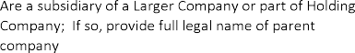 | N/A
 |  | 1
 |  | Jacob Bevier
 |  | Founder/CEO
 |  | 105 Pendleton Trail, Tyrone, GA 30290
 |  | 760 490-3416
 |  | bevier19jac@icloud.com
 |  | 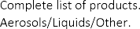 | Aerosols
 |  | 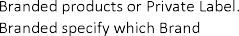
 | 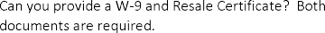
 |  |  | Yes

